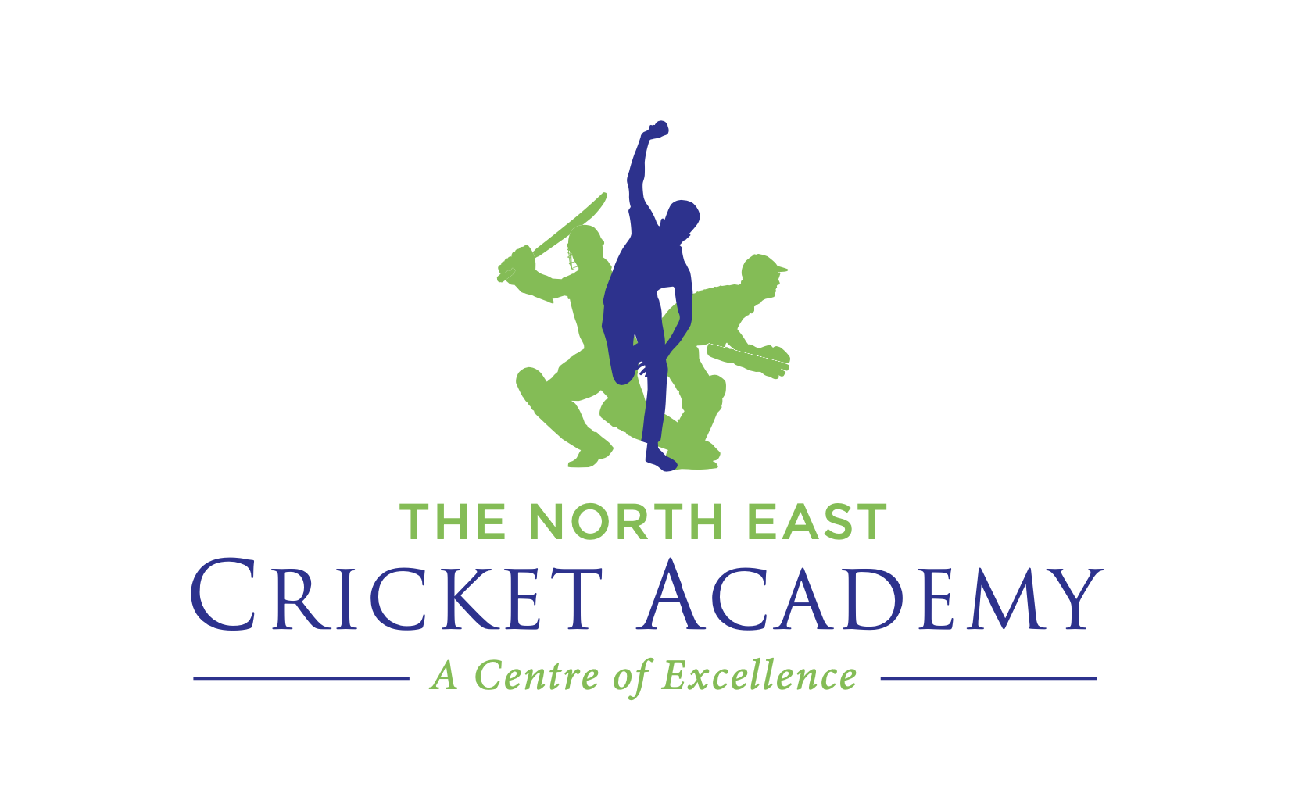

NECA Elite Pre-Season Programme Expression of Interest

The North East Cricket Academy are now taking expressions of interest for our Elite Pre-Season Programmes. These programmes start in w/c 16th January 2023 and will be running at both U13 and U15 age groups.
Our Elite programmes are aimed at young players who have already played or are ready to play representative cricket, and we work to make sure their game is in the best possible position heading into the upcoming season.

Application Process:
The attached form needs to be completed and returned to Ruaidhri Fletcher, Director of Coaching, by Wednesday 9th November.

Please note that players currently taking part in our Elite Player Development Programmes do not need to express their interest. Invitations will be sent out on Thursday 10th November.

Please email the attached form to:
ruaidhrifletcher@southnorth.co.uk

All information filled out on the form is considered confidential

Player Information:
Name of Player:
Date of Birth:
Course applying for:

Personal Information:
Parent’s Name:
Mobile:
Email Address:
Address:

Cricket Club:
Club Contact:
School:

Player’s Cricket Background & Cricketing Ambition:

What characteristics & traits would the player bring to the course:

