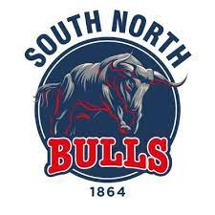

Junior Member Policies
Using the Code of Conduct for cricket Members and Guests, and consulting with all the junior members at the cricket club, we have created a specific code of conduct for the junior members relating to their time at South Northumberland CC.
South Northumberland CC is fully committed to safeguarding and promoting the wellbeing of all its members.
South Northumberland CC believes that it is important that members, coaches, administrators and parents/carers or guardians associated with the club should, at all times, show respect and understanding for the safety and welfare of others.
Therefore, members are encouraged to be open at all times and to share any concerns or complaints that they may have about any aspect of the club with Child Welfare Officer, Alan Fletcher.
As a member of South Northumberland Cricket Club you are expected to abide by the following junior code of conduct:
- All members must play within the rules and respect officials and their decisions.
- All members must respect the rights, dignity and worth of all participants regardless of gender, ability, cultural background or religion.
- Members should keep to agreed timings for training and competitions or inform their coach or team manager if they are going to be late.
- Members must wear suitable kit (Helmet, Box) at all times during matches and practice as agreed by the team manager/coach.
- Members must pay any fees for training or events promptly.
- Junior members are not allowed to smoke on club premises or whilst representing the club at competitions.
- Junior members are not allowed to consume alcohol or drugs of any kind on the club premises or whilst representing the club.
This code of conduct was formally adopted on 10 July 2018 and formally reviewed on the 13/01/2022

